LAB INDEX

NAME: Vivek Kumar SUBJECTNAME: Project Based Learning in Java Lab

UID: 21BCS8129 SUBJECTCODE: 20CSP-314

SECTION: WM-20BCS-616/A

|  |  |  |  |  |  |  |  |
| --- | --- | --- | --- | --- | --- | --- | --- |
| **Sr.No** | **Program** | **Date** | **Evaluation** | | | | **Sign** |
| **LW**  **(12)** | **VV**  **(10)** | **FW**  **(8)** | **Total**  **(30)** |
| 1 | Create an application to save the employee information using arrays. | 09-08-2022 |  |  |  |  |  |
| 2 | Design and implement a simple inventory control system for a small video rentalstore. | 23-08-2022 |  |  |  |  |  |
| 3 | Create a application to calculate interest for FDs, RDs based on certain conditions using inheritance. | 02-09-2022 |  |  |  |  |  |
| 4 | Create a program to show the usage of Sets of Collection interface. | 27-09-2022 |  |  |  |  |  |
| 5 | Create a program to set view of Keys from Java Hashtable. | 27-09-2022 |  |  |  |  |  |
| 6 | Write a Program to perform the basic operations like insert, delete, display and search in list. List contains String object items where these operations are to be performed. | 04-10-2022 |  |  |  |  |  |
| 7 | Create a menu-based Java application with the following options.1. Add an Employee2.Display All3.Exit If option 1 is selected, the application should gather details of the employee like employee name, employee id, designation and salary and store it in a file. If option 2 is selected, the application should display all the employee details. If option 3 is selected the application should exit. | 14-10-2022 |  |  |  |  |  |
| 8 | Create a palindrome creator application for making a longest possible palindrome out of given input string. | 01-11-2022 |  |  |  |  |  |
| 9 | Create a Servlet/ application with a facility to print any message on web browser. | 10/11/2022 |  |  |  |  |  |
| 10 | Create JSP application for addition, multiplication and division. |  |  |  |  |  |  |

## CHANDIGARH UNIVERSITY

## UNIVERSITY INSTITUTE OF NGINEERING

**DEPARTMENT OF COMPUTER SCIENCE & ENGINEERING**



|  |  |
| --- | --- |
| **Submitted By: Submitted To:**  Vivek Kumar(21BCS8129) Neeru Sharma(E12950) | |
| **Subject Name** | Project Based Learning in Java Lab |
| **Subject Code** | 20CSP-321 |
| **Branch** | Computer Science and Engineering |
| **Semester** | 5th |

**Experiment - 9**

**Student Name: Vivek Kumar UID: 21BCS8129**

**Branch: BE-CSE(LEET) Section/Group:20BCS-WM-616/A**

**Semester: 5th Date of Performance: 01/11/2022**

**Subject Name:** **Project Based Learning in Java Lab Subject Code: 20CSP-321**

1. **Aim/Overview of the practical:**

Create a program that uses JSP and html to insert, edit, delete or view employee data from a database. You have to use JSP bean class to set values for employee objects.

1. **Task to be done/ Which logistics used:**

Create a program that uses JSP and html to insert, edit, delete or view employee data from a database. You have to use JSP bean class to set values for employee objects.

1. **Apparatus / Simulator Used:**

* Eclipse IDE - (Java)
* NetBeans.
* JDK-8 or any.

1. **Programs/ Code:**

**index.html**

<!DOCTYPE html>

<html>

<head>

<meta charset="ISO-8859-1">

<title>Insert</title>

</head>

<body>

<h1>Add New Employee</h1>

<form action="addition.jsp">

<table>

<tr><td>Name:</td><td><input type="text" name="name"/></td></tr>

<tr><td>Age:</td><td><input type="text" name="age"/></td></tr>

<tr><td>Salary:</td><td><input type="text" name="salary"/></td></tr>

<tr><td>Experience:</td><td><input type="text" name="exp"/></td></tr>

<tr><td colspan="2"><input type="submit" value="Insert"/></td></tr>

</table>

</form>

<a href="delete.html">delete employees</a>

<br><br>

<a href="ViewServlet">view employees</a>

</body>

</html>

**addition.jsp**

<%@ page language="java" contentType="text/html; charset=ISO-8859-1"

pageEncoding="ISO-8859-1" import="abc.employee" import="abc.employeeDb" %>

<!DOCTYPE html>

<html>

<head>

<meta charset="ISO-8859-1">

<title>Insert title here</title>

</head>

<body>

<%! String Name;%>

<%! int Empid,age,Salary,experience; %>

<%

Name=request.getParameter("name");

age=Integer.parseInt(request.getParameter("age"));

Salary=Integer.parseInt(request.getParameter("salary"));

experience=Integer.parseInt(request.getParameter("exp"));

%>

<jsp:useBean id="ob" class="abc.employee"></jsp:useBean>

<jsp:setProperty property="*" name="ob"/>

<jsp:setProperty property="experience" value="<%= experience %>" name="ob" />

<%

employeeDb ob1=new employeeDb();

if(ob1.insert(ob))

out.print("<p>Insertion succesful</p>");

else

out.print("Insertion failed");

out.print("<a href=\"index.html\">Add New Employee</a><br></br>");

out.print("<a href=\"delete.html\">Delete Employee</a><br></br>");

out.print("<a href=\"ViewServlet\">view employees</a>");

%>

</body>

</html>

**delete.html**

<!DOCTYPE html PUBLIC "-//W3C//DTD HTML 4.01 Transitional//EN"

"http://www.w3.org/TR/html4/loose.dtd">

<html>

<head>

<meta http-equiv="Content-Type" content="text/html; charset=ISO-8859-1">

<title>Insert title here</title>

</head>

<body>

<form action="deletion.jsp">

Empid:<input type="text" name="empid1">

<input type="submit" value="delete">

</form>

</body>

</html>

**deletion.jsp**

<%@ page language="java" contentType="text/html; charset=ISO-8859-1"

pageEncoding="ISO-8859-1" import="abc.employee" import="abc.employeeDb" %>

<!DOCTYPE html>

<html>

<head>

<meta charset="ISO-8859-1">

<title>Insert title here</title>

</head>

<body>

<%! String Empid; %>

<%

Empid=request.getParameter("empid1");

%>

<jsp:useBean id="ob" class="abc.employeeDb"></jsp:useBean>

<%

if(ob.delete(Integer.parseInt(Empid)))

out.print("<p>Deletion succesful</p>");

else

out.print("<p>Deletion Failed</p>");

out.print("<a href=\"index.html\">Add New Employee</a><br></br>");

out.print("<a href=\"delete.html\">Delete Employee</a><br></br>");

out.print("<a href=\"ViewServlet\">View Employees</a>");

%>

</body>

</html>

**employee.java**

package abc;

public class employee

{

String Name;

int age;

int Salary;

int Empid;

int experience;

public String getName() {

return Name;

}

public void setName(String name) {

Name = name;

}

public int getAge() {

return age;

}

public void setAge(int age) {

this.age = age;

}

public int getSalary() {

return Salary;

}

public void setSalary(int salary) {

Salary = salary;

}

public int getEmpid() {

return Empid;

}

public void setEmpid(int empid) {

Empid = empid;

}

public int getExperience() {

return experience;

}

public void setExperience(int experience) {

this.experience = experience;

}

}

**employeeDb.java**

package abc;

import java.sql.*;

import java.util.ArrayList;

import java.util.List;

public class employeeDb

{

static Connection con;

Statement stmt;

ResultSet rs;

public boolean insert(employee e) throws SQLException

{

try {

Class.forName("oracle.jdbc.driver.OracleDriver");

con=DriverManager.getConnection("jdbc:oracle:thin:@localhost:1521:xe","system","123");

stmt=con.createStatement();

stmt.executeUpdate("insert into employees

values(seq_emp.nextval,'"+e.Name+"','"+e.age+"','"+e.Salary+"','"+e.experience+"')");

return true;

}

catch(Exception ex)

{

return false;

}

}

public boolean delete(int e) throws SQLException

{

try {

Class.forName("oracle.jdbc.driver.OracleDriver");

con=DriverManager.getConnection("jdbc:oracle:thin:@localhost:1521:xe","system","123");

stmt=con.createStatement();

stmt.executeUpdate("delete from employees where ID='"+e+"'");

return true;

}

catch(Exception ex)

{

return false;

}

}

public static List<employee> getAllEmployees(){

List<employee> list=new ArrayList<employee>();

try{

Class.forName("oracle.jdbc.driver.OracleDriver");

con=DriverManager.getConnection("jdbc:oracle:thin:@localhost:1521:xe","system","123");

PreparedStatement ps=con.prepareStatement("select * from

employees");

ResultSet rs=ps.executeQuery();

while(rs.next()){

employee e=new employee();

e.setName(rs.getString(2));

e.setAge(rs.getInt(3));

e.setEmpid(rs.getInt(1));

e.setExperience(rs.getInt(5));

e.setSalary(rs.getInt(4));

list.add(e);

}

con.close();

}

catch(Exception e){e.printStackTrace();

}

return list;

}

}

**ViewServlet.java**

import java.io.IOException;

import java.io.PrintWriter;

import java.util.List;

import javax.servlet.ServletException;

import javax.servlet.annotation.WebServlet;

import javax.servlet.http.HttpServlet;

import javax.servlet.http.HttpServletRequest;

import javax.servlet.http.HttpServletResponse;

import abc.employee;

import abc.employeeDb;

@WebServlet("/ViewServlet")

public class ViewServlet extends HttpServlet {

protected void doGet(HttpServletRequest request, HttpServletResponse response)

throws ServletException, IOException {

response.setContentType("text/html");

PrintWriter out=response.getWriter();

out.println("<a href='index.html'>Add New Employee</a><br></br>");

out.println("<a href='delete.html'>Delete an Employee</a>");

out.println("<h1>Employees List</h1>");

List<employee> list=employeeDb.getAllEmployees();

out.print("<table border='1' width='100%'");

out.print("<tr><th>Id</th><th>Name</th><th>Age</th><th>Salary</th><th>Experien

ce</th></tr>");

for(employee e:list){

out.print("<tr><th>"+e.getEmpid()+"</th><th>"+e.getName()+"</th><th>"+e.getAge()

+"</th><th>"+e.getSalary()+"</th><th>"+e.getExperience()+"</th></tr>\"");

}

out.print("</table>");

out.close();

}

}

1. **Result/Output/Writing Summary:**

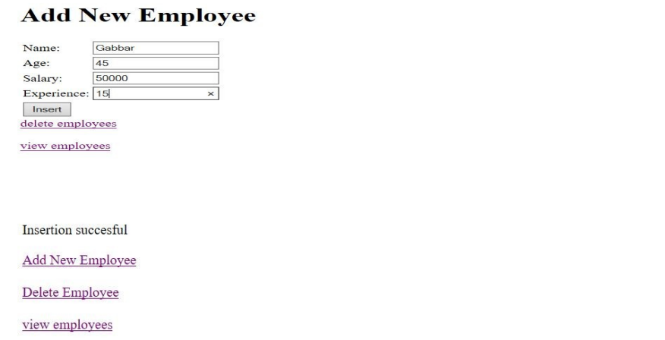

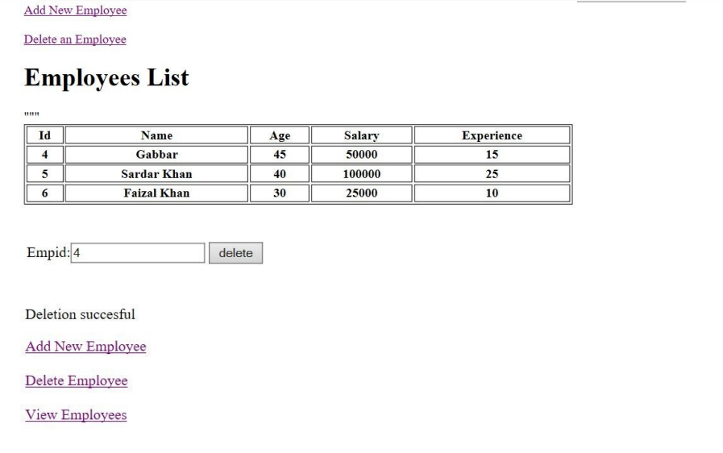

I have successfully done this program.

**Learning Outcomes (What I have learnt):**

* Learnt the concept of servelet.
* Learnt the concept of JSP.
* Learnt a program that uses JSP and html to insert, edit, delete or view employee data from a database.

**Evaluation Grid (To be created per the faculty's SOP and Assessment guidelines):**

|  |  |  |  |
| --- | --- | --- | --- |
| Sr. No. | Parameters | Marks Obtained | Maximum Marks |
| 1. | Worksheet completion including writing learning objectives/Outcomes.  (To be submitted at the end of the day). |  |  |
| 2. | Post-Lab Quiz Result. |  |  |
| 3. | Student Engagement in  Simulation/Demonstration/Performance and Controls/Pre-Lab Questions. |  |  |
|  | Signature of Faculty (with Date): | Total Marks Obtained: |  |